The SmartUnit test runner allows the execution of AblUnit tests. The annotations of SmartUnit are compatible with the annotations used by AblUnit (SmartUnit however does support a few additional Test annotation attributes, like StopAfter).

AblUnit does not support the execution of Unit tests in the Progress Developer Studio for OpenEdge integrated debugger. Using a “Run Configuration” the debug launcher of SmartUnit can fill this gap.

Create the following “Run Configuration”:

Startup program: “Run this program” and then “Consultingwerk\SmartUnit\debugtest.p”.

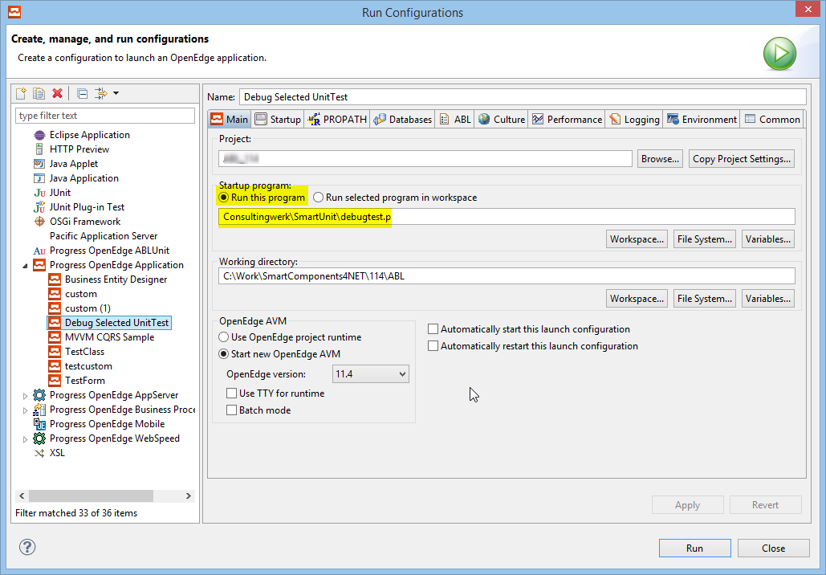

As the „Session startup parameter“ enter „${resource_loc}“.

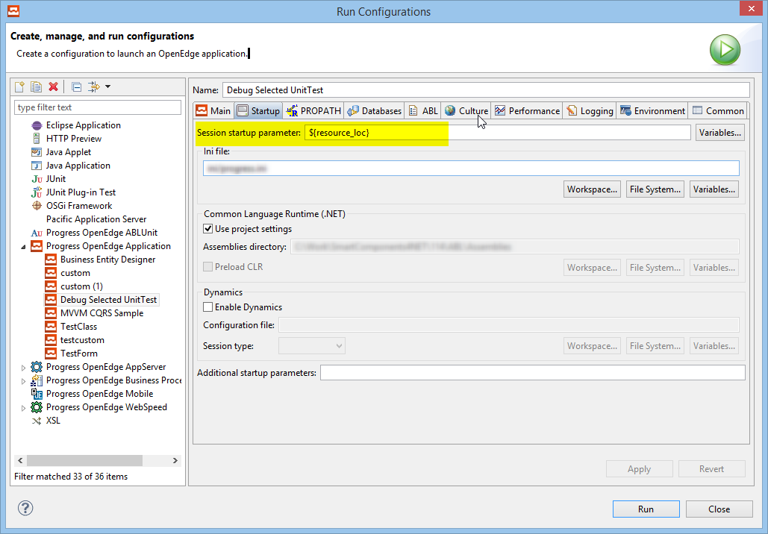

We recommend to store this run configuration as a „Shared file“ and display it in the favorites menu for both “Debug” and “Run”.

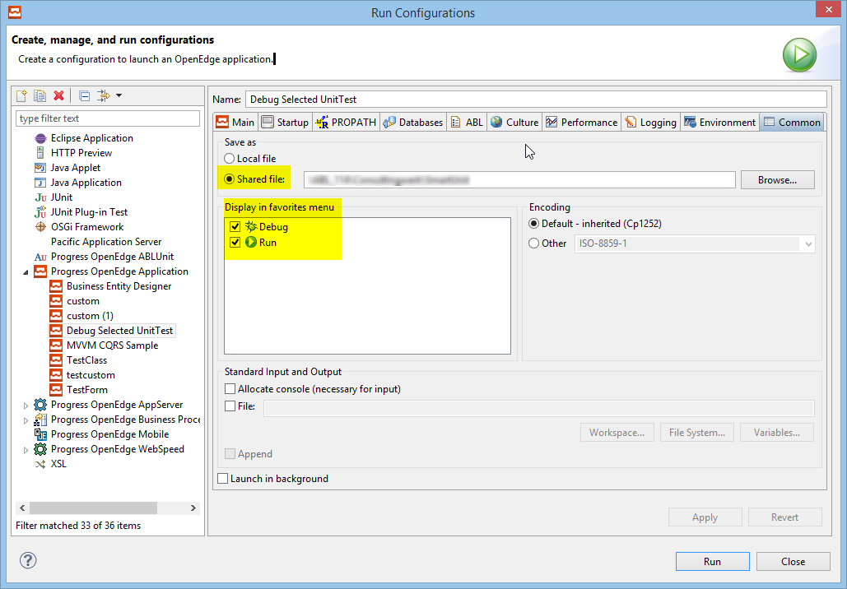

Using this run configuration you can select an AblUnit or SmartUnit test class and execute the debug run configuration either for run or debug. We recommend that you create a break point in the test method that you’d like to debug. This allows to avoid stepping through the SmartUnit test engine itself.